NALAIYA THIRAN

WEEK 2 REPORT

Phase 2 Description: Ideation Phase (Literature Survey, Empathize, Defining Problem Statement, Ideation)

**Team Leader :**SOORAJ K

**Team member :** RAM BALAJI

**Team member :**PRASSANA KUMAR

**Team member :** PRAVEEN RAJ S

**Team member :** RITHVIK THOTA

Activities for Week 2:

2.1 Literature survey on the selected project & Information Gathering

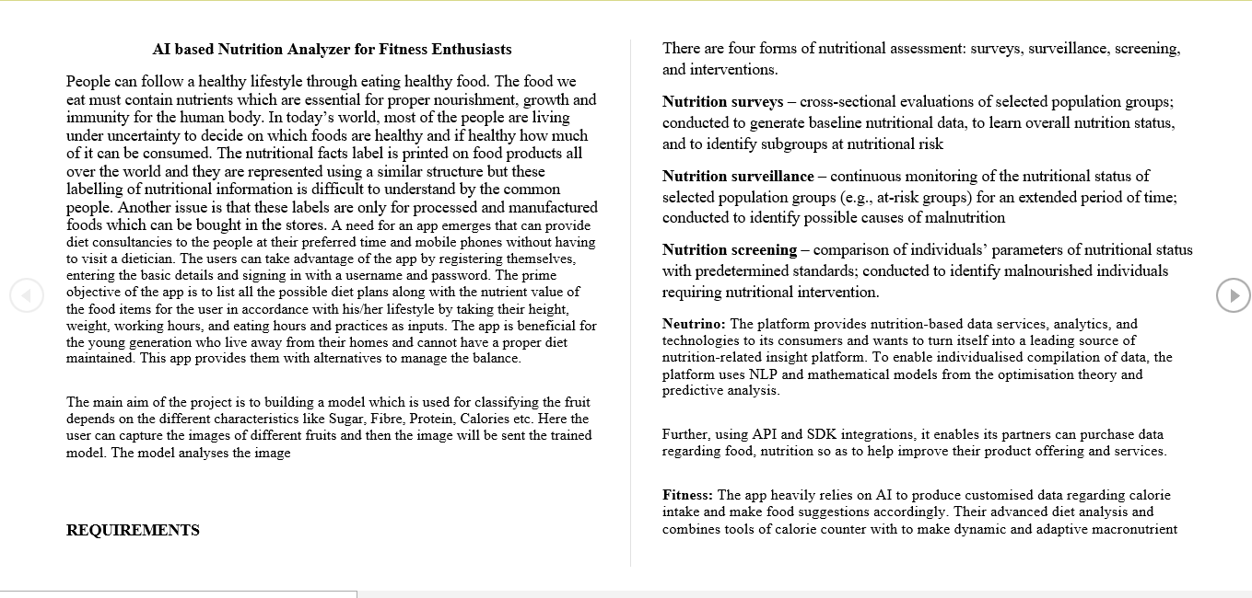

2.2 Attend the technology trainings as per the training calendar

Literature survey has been done with existing models.

Attended technology trainings as per the training calendar.